System and Software Architecture Description (SSAD)

Surgery Assist
Name | Primary Role | Secondary Role
Yu Fang | Project Manager | Life Cycle Planner
Yu Zhang | Software Architecture | Prototyper
Heguang Liu | Operational Concept Engineer | Software Architecture
Wanghai Gu | Life Cycle Planner | Operational Concept Engineer
Zhen Li | Feasibility Analyst | Requirement Engineer
Longfeng Jia | Prototyper | Feasibility Analyst
Xiheng Yue | QFP | UML Moduler

Team 11

Version History
Date | Author | Version | Changes made | Rationale
09/26/13 | Y.Z. | 1.0 | - All details known as of 09/26/13 | - Initial Draft
10/03/13 | Y.Z | 1.1 | - Finish all of Section 1 and part of Section 2 | - Update System Context diagram and Artifacts & Information diagram
10/11/13 | Y.Z. | 1.2 | - Finnish all of Section 2 | - Update use case diagram and description
10/16/13 | Y.Z. | 1.3 | - Modify Section 2.1.3 | - Make modification according to ARB Feedback
11/02/13 | Y.Z. | 2.0 | - Add Section 3 | - Initial draft of NDI/NCS analysis
11/10/13 | H.L. | 2.1 | - Add Section 4.1.2 | - Initial draft of Class Design Diagram
11/12/13 | Y.Z. | 2.2 | - Add Section 4.1.1 and 4.1.3 | - Initial draft of component class diagram and sequence diagram
11/22/13 | H.L | 2.3 | - Update Section 4.1.2 | - Modify Class Design Diagram
11/25/13 | Y.Z | 2.4 | - Update Section 4.1.3 | - Modify sequence diagram
12/01/13 | Y.Z | 3.0 | - Finish Draft Version of SSAD | - Organize diagrams and tables
12/06/13 | Y.Z | 3.2 | - Made modification and fix | - Modify according to the ARB feedback

Table of Contents
System and Software Architecture Description (SSAD) i
Version History ii
Table of Contents iii
Table of Tables iv
Table of Figures v
1. Introduction 1
1.1 Purpose of the SSAD 1
1.2 Status of the SSAD 1
2. System Analysis 2
2.1 System Analysis Overview 2
3. NDI/NCS Interoperability Analysis 25
3.1 Introduction 25
3.2 System Structure 26
3.3 Evaluation Summary 26
4. Technology-Specific System Design 29
4.1 Design Overview 29

Table of Tables
Table 1: Actors Summary 3
Table 2: Artifacts and Information Summary 4
Table 3: NDI Products Listing 25
Table 4: NDI Evaluation 26

Table of Figures
Figure 1: System Context Diagram 2
Figure 2: Artifacts and Information Diagram 3
Figure 3 Process Diagram 4
Figure 4 System Structure Diagram 26
Figure 5 Hardware Component Class Diagram 29
Figure 6 Software Component Class Diagram 30
Figure 7 Deployment Diagram 31
Figure 8 Design Class Diagram 32
Figure 9 Reservation Sequence Diagram 33
Figure 10 Login Sequence Diagram 34

Introduction

Purpose of the SSAD

The purpose of this SSAD is to record the results of the design and analysis of our Surgery Assistant Web System. Developers can use this SSAD as reference to the architecture of the system when writing implementation code in the development phase.

Status of the SSAD

The current version of this SSAD is 3.2. In this version, we do all necessary modification and fix for this documentation according to the feedback from Professors and Client in the ARB presentation. This will be the final version of SSAD document for our team.

System Analysis

System Analysis Overview
The main purpose of Surgery Assistant is to provide a platform for surgery centers to post available surgical slot to our system, then doctors are able to find surgical slot more efficiently using the search function of our system and make reservation to the surgical slots.
In a word, Surgery Assistant builds a provider and consumer relationship between surgery centers and doctors so they can communicate more directly about the usage of surgical slot. This will help both sides work more efficiently.

System Context
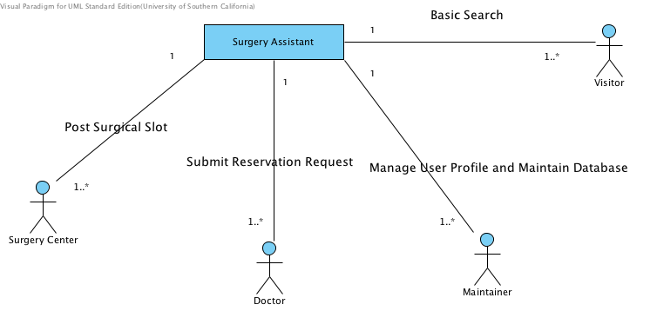
Figure 1: System Context Diagram

Table 1: Actors Summary
Actor | Description | Responsibilities
Surgery Center | Users who provide surgical slot | Provide Surgical Slot Information  Approve/Decline reservation request from doctors
Doctor | Users who reserve surgical slot | Make surgical slot reservation
Maintainer | System administrator | Monitor system running situation and conduct maintenance and user management job
Visitor | Users who don’t register as a formal user | Do some basic search

Artifacts & Information
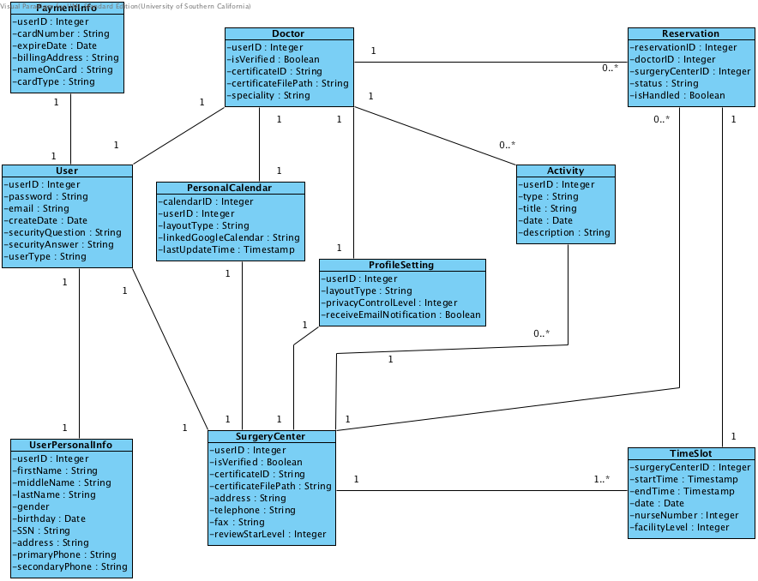
Figure 2: Artifacts and Information Diagram

Table 2: Artifacts and Information Summary
Artifact | Purpose
User | Store User account information including ID, password, email
UserPersonalInfo | Store User personal information such as name and birthday
PaymentInfo | Store payment credit card information of a user
Doctor | Store all specific information for Doctor users
SurgeryCenter | Store all specific information for Surgery Center users
PersonalCalendar | Store a user’s Google calendar information used to synchronize user’s schedule information
ProfileSetting | Store settings information of a user’s profile and account
Activity | Store activity history of a user
TimeSlot | Store information of posted time slot

Behavior
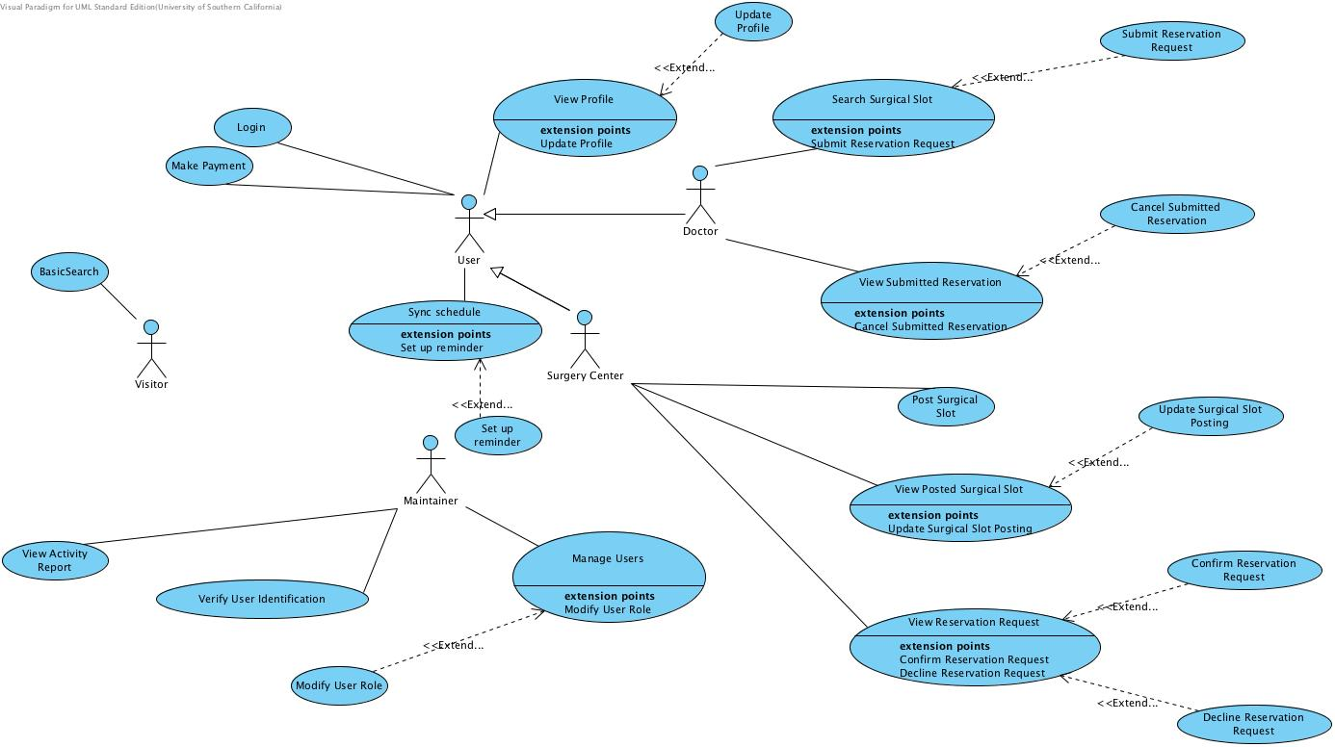
Figure 3 Process Diagram

Use Case Description

Login
Main
Identifier | UC-01: Login
Purpose | Authorize a user to log into the system and determine the user’s role and access privileges.
Requirements | WC_2753: As a doctor / SC, I can log in/off the system.
Development Risk | None
Preconditions | System database is properly initialized
Post-conditions | 1. If the user login successfully, the user is able to access system with the access privileges of the user role  2. If the user log in information is not valid, the system informs the user that she/he has entered an invalid username and password
Flow of Events
   | Actor Input | System Response
  1 | Enter a username and password
  2 | Click the “Login” button
  3 |  | Validate username and password
  4 |  | Redirect the user to their personal home page
Alternate
   | Actor Input | System Response
  1 | Enter a username and password
  2 | Click the “Login” button
  3 |  | Validate username and password
  4 |  | Redirect the user to the login page and informs the user that he/she has entered an invalid username or password.
Exceptional
   | Actor Input | System Response
  1 | Unsuccessfully attempt to log in to the system four consecutive times
  2 |  | Disable the user's privilege to login.
  3 |  | Notify the user that he/she will have to contact the administrator.

View Profile
Extension Points
Update Profile

Identifier | UC-04: View profile
Purpose | Allow the system users to view their profiles
Requirements | WC_2754: As a doctor / SC, I can create/update my profile.  WC_2426: As a doctor / SC I can view doctor/ SC profiles
Development Risk | None
Preconditions | User is logged into the system.
Post-conditions | User profile is displayed to the user.
Flow of Events
   | Actor Input | System Response
  1 | Click “View Profile”
  2 |  | The user profile is displayed to the user.

Update Profile
Identifier | UC-05: update profile
Purpose | Enable users to edit their profiles.
Requirements | WC_2754: As a doctor / SC, I can create/update my profile.
Development Risk | None
Preconditions | User logs into the system
Post-conditions | User updated profile successfully
Flow of Events
   | Actor Input | System Response
  1 | Click “Profile”.
  2 |  | Display the profile information.
  3 | Click “Edit”.
  4 | Filled in all required fields
  5 |  | Validate that if the user has filled all the required fields.
  6 |  | Notify the user that profile has been updated in the system

Make Payment
Identifier | UC26: Make payment
Purpose | Allow the user to make payment online
Requirements | WC_2425: As a doctor / SC I can make a payment
Development Risk | None
Preconditions | User is logged into the system
Post-conditions | The payment has been made successfully
Flow of Events
   | Actor Input | System Response
  1 | Click "Make a payment"
  2 | Input credit card information
  3 |  | Displaying a message showing that the payment has been made successfully
Exceptional
   | Actor Input | System Response
  1 | Click "Make a payment"
  2 | Input credit card information
  3 |  | Displaying a message showing that transaction has been denied and ask user to check credit card information

Manage Users
Extension Points
Modify User Role

Identifier | UC-20: Manage users
Purpose | Allow the maintainer to view details of all current users
Requirements | WC_2766: As a maintainer I can view/create/update/delete profiles of every doctor/SC.
Development Risk
Preconditions | User is logged into the system as maintainer
Post-conditions | A list of current users is displayed
Flow of Events
   | Actor Input | System Response
  1 | Click "View Current Users"
  2 |  | Display a list of current users

Modify User Role
Identifier | UC-21: Modify user role
Purpose | Maintainer is able to modify user role
Requirements | WC_2767: As a maintainer I can modify the role of a doctor/SC
Development Risk
Preconditions | A list of current users is displayed
Post-conditions | user's role is modified and saved in the database
Flow of Events
   | Actor Input | System Response
  1 | Select one user
  2 | Choose “Option”
  3 | Click on “Change role”
  4 | Choose the new role
  5 |  | System modifies the specified use's roles.
  6 |  | Display a message showing that the role has been updated

Verify User Identification
Identifier | UC-19: Verify user identification
Purpose | Allow the maintainer to verify the user's valid identification
Requirements | WC_2765: As a maintainer I can verify the validity of a doctor/SC's identification.
Development Risk
Preconditions | User is logged into system as Maintainer
Post-conditions | 1. If the user identification is valid, the new user account is created  2. If the user identification is not valid, registration request is declined  In both cases, an notification email will be sent to the user
Flow of Events
   | Actor Input | System Response
  1 | Click "View registration request"
  2 |  | A list of registration request is displayed
  3 | Select one request and click "approve"
  4 |  | Displaying a message showing that the new user account is created
Alternate
   | Actor Input | System Response
  1 | Click "View registration request"
  2 |  | A list of registration request is displayed
  3 | Select one request and click "decline"
  4 |  | Displaying a message showing that the registration request is declined

View Activity Report
Identifier | UC-18: View activity report
Purpose | Allow the Project Owner to view an activity report
Requirements | WC_2764: As a maintainer, I can view/generate an activity report.
Development Risk
Preconditions | User is logged into the system as Project Owner.
Post-conditions | Reservation activity reports of selected time periods are displayed to the user
Flow of Events
   | Actor Input | System Response
  1 | Click “View Report”
  2 | Select time periods
  3 |  | A reservation report of selected time period is displayed to the Project Owner

Post Surgical Slot
Identifier | UC-11: Post Surgical Slot
Purpose | Allow the Surgery Center users to post Surgical slot to the Online System
Requirements | WC_2775: As a surgery center, I can post a surgical slot.
Development Risk
Preconditions | User is logged into the system as Surgery Center user
Post-conditions | Surgical Slot information is available from the online system
Flow of Events
   | Actor Input | System Response
  1 | Attempt to create a surgical slot posting
  2 |  | Check web page for completeness
  3 |  | Display a message to indicate the surgical slot posting is updated
Exceptional
   | Actor Input | System Response
  1 | Attempt to create a surgical slot post
  2 |  | Check web page for completeness
  3 |  | Reload the web page and indicate which required information was not completed

View Posted Surgical Slot
Extension Points
Update Surgical Slot Posting

Identifier | UC-12: View posted surgical slot post
Purpose | Allow the Surgery Center users to view surgical slot post
Requirements | WC_2761: As a surgery center, I can view/update my surgical slot post.
Development Risk
Preconditions | User is logged into the system as Surgery Center user
Post-conditions | Surgical slot post is displayed to the Surgery Center user
Flow of Events
   | Actor Input | System Response
  1 | Click “View Surgical slot Post”
  2 | Choose “by time” or “by status”
  3 |  | Surgical slot posting is displayed to the Surgery Center user
Exceptional
   | Actor Input | System Response
  1 | Click “View Surgical slot Post”
  2 | Choose “by time” or “by status”
  3 |  | Display a message saying that “there is no existing surgical slot post” and redirect to the Profile page

Update Surgical Slot Posting
Identifier | UC-13: Update Surgical Slot Post
Purpose | Allow the Surgery Center users to update the surgical slot post
Requirements | WC_2761: As a surgery center, I can view/update my surgical slot post
Development Risk
Preconditions | Surgical slot post is displayed to the Surgery Center user
Post-conditions | Surgical slot post is updated in the database.
Flow of Events
   | Actor Input | System Response
  1 | Click “Update”
  2 | Fill in all required fields
  3 | Click “Submit”
  4 |  | Check fields for completeness
  5 |  | Display a message to indicate that the surgical slot post is updated successfully
Exceptional
   | Actor Input | System Response
  1 | Click “Update”
  2 |  | Reload the form page and indicate that confirmed post cannot be updated
Exceptional
   | Actor Input | System Response
  1 | Click “Update”
  2 | Fill all required fields
  3 | Click “Submit”
  4 |  | Check for completeness
  5 |  | Reload the form page and indicate which fields are not complete

View Reservation Request
Extension Points
Confirm Reservation Request

Decline Reservation Request

Identifier | UC-14: View reservation request
Purpose | Allow Surgery Centers to view received reservation request
Requirements | WC_2763: As a surgery center, I can view/confirm/decline a reservation request.
DevelopmentI Risk
Preconditions | User is logged into the system as Surgery Center user
Post-conditions | All received reservation requests are displayed to the Surgery Center user.
Flow of Events
   | Actor Input | System Response
  1 | Click “View Reservation Requests”
  2 | Select time period
  3 |  | The reservation requests are displayed to the Surgery Center user.
Alternate
   | Actor Input | System Response
  1 | Click “View Reservation requests”
  2 | Select time period
  3 |  | Display a message indicating that “You have no received reservation request”.

Confirm Reservation Request
Identifier | UC-15: Confirm reservation request
Purpose | Allow Surgery Center user to confirm reservation request sent from Doctors
Requirements | WC_2763: As a surgery center, I can view/confirm/decline a reservation request.
Development Risk
Preconditions | All received reservation requests are displayed to the Surgery Center user.
Post-conditions | 1. The reservation request is marked as confirmed in the database  2. A notification will be sent to the Doctor who made this request
Flow of Events
   | Actor Input | System Response
  1 | Click “View Unconfirmed Reservation Requests”
  2 |  | A list of unconfirmed reservation is displayed to the user
  3 | Click “confirm” button next to a reservation request
  4 |  | A message displays showing that the reservation request has been confirmed
Alternate
   | Actor Input | System Response
  1 | Click “View Unconfirmed Reservation Requests”
  2 |  | Display a message showing that “You don’t have any unconfirmed Reservation Requests”

Decline Reservation Request
Identifier | UC-16: Decline reservation request
Purpose | Allow Surgery Center user to decline reservation request sent from Doctors
Requirements | WC_2763: As a surgery center, I can view/confirm/decline a reservation request.
Development Risk
Preconditions | All received reservation requests are displayed to the Surgery Center user.
Post-conditions | 1. The reservation request is marked as declined in the database  2. An email notification will be sent to the Doctor who made this request
Flow of Events
   | Actor Input | System Response
  1 | Click “View Unconfirmed Reservation Requests”
  2 |  | A list of unconfirmed reservation is displayed to the user
  3 | Click “decline” button next to a reservation request
  4 |  | Prompt for decline reason input
  5 | Enter the decline reason and click “Send”
  6 |  | A message displays showing that the reservation request has been declined
Alternate
   | Actor Input | System Response
  1 | Click “View Unconfirmed Reservation Requests”
  2 |  | Display a message showing that “You don't have any unconfirmed Reservation Requests”

Search Surgical Slot
Extension Points
Submit Reservation Request

Identifier | UC-07: Search surgical slot
Purpose | Allow a doctor to search for available surgical slot online
Requirements | WC_2739: As a doctor, I can search for the surgery center by name/location  WC_2432: As a doctor I can pick the top five SC according to my preference
Development Risk
Preconditions | User is logged into the system as Doctor
Post-conditions | Available surgical slots are displayed to Doctor
Flow of Events
   | Actor Input | System Response
  1 | Choose to search for a Surgery Center by “location, by “name”or by "preference"
  2 |  | A list of Surgery Centers is displayed
  3 | Select a Surgery Center
  4 |  | All available up to date surgical slot for the selected surgery center is displayed in the calendar format
Exceptional
   | Actor Input | System Response
  1 | Choose to search for a Surgery Center by “location”,by “name”or by "preference"
  2 |  | Display a message showing “there is no such a surgery center exists, please input another name or choose another area”

Submit Reservation Request
Identifier | UC-09: Submit Reservation Request
Purpose | Allow Doctors to submit a surgical slot reservation request form
Requirements | WC_2774: As a doctor I can make a surgical slot reservation request.
Development Risk
Preconditions | Available surgical slots are displayed to Doctor
Post-conditions | A surgical slot reservation form is submitted
Flow of Events
   | Actor Input | System Response
  1 | Select a surgical slot to reserve
  2 | Fill in all required fields
  3 | Click “Submit”
  4 |  | Check form for completeness
  5 |  | Display a message to indicate that the form has been submitted
Exceptional
   | Actor Input | System Response
  1 | Select a surgical slot to reserve
  2 | Fill in all required fields
  3 | Click “Submit”
  4 |  | Check form for completeness
  5 |  | Display a error message showing which required fields are missing

View Submitted Reservation
Extension Points
Cancel Submitted Reservation

Identifier | UC-08: view submitted reservation
Purpose | Allow the Doctors to view their submitted reservation
Requirements | WC_2734: As a doctor I can view/cancel a submitted surgical slot reservation request.
Development Risk
Preconditions | User is logged into the system as a Doctor
Post-conditions | A list of submitted reservation is shown to the Doctor
Flow of Events
   | Actor Input | System Response
  1 | Click “View Submitted Reservation”
  2 |  | Display list of all submitted reservation
Exceptional
   | Actor Input | System Response
  1 | Click “View Submitted Reservation”
  2 |  | Display a message showing "You do  not have any submitted reservation"

Cancel Submitted Reservation
Identifier | UC-10: Cancel submitted reservation
Purpose | Allow Doctors to cancel submitted reservations
Requirements | WC_2734: As a doctor I can view/cancel a submitted surgical slot reservation request.
Development Risk
Preconditions | A list of submitted reservation is shown to the Doctor
Post-conditions | 1. An alert regarding the canceled reservation is sent to the corresponding surgery center  2. The corresponding reservation form is deleted from database
Flow of Events
   | Actor Input | System Response
  1 | Click “Cancel”
  2 |  | Display a message to indicate that the reservation has been canceled

Sync schedule
Extension Points
Set up reminder

Identifier | UC31: Sync schedule
Purpose | Allow the user to sync reservation schedule with google calendar
Requirements | WC_2429: As a doctor / SC I can sync reservations with my Google calendar.
Development Risk | None
Preconditions | User is logged into the system
Post-conditions | Reservation schedule is synced with user's google calendar
Flow of Events
   | Actor Input | System Response
  1 | Click "View reservation schedule"
  2 | Click "Sync with my google calendar"
  3 |  | Display a message showing that the schedule information has been synced with google calendar

Set up reminder
Identifier | UC32: Set up reminder
Purpose | Allow the user to set up a reminder for their reservation schedule
Requirements | WC_2434: As a doctor / SC I can set up a reminder for surgery schedule.
Development Risk | None
Preconditions | Reservation schedule is synced with google calendar
Post-conditions | A reminder is set successfully for the schedule
Flow of Events
   | Actor Input | System Response
  1 | Click "Set up a reminder"
  2 | Input a time
  3 |  | Display a message showing that the reminder has been set up successfully
Exceptional
   | Actor Input | System Response
  1 | Click "Set up a reminder"
  2 | Input a time
  3 |  | Display an error message showing that the time format is not valid

NDI/NCS Interoperability Analysis

Introduction
In our Surgery Assist Project, Java Spring Framework will be used as the main development platform. JDBC will be used to connect with Microsoft SQL Server to implement the data query. Some network services, such as Google Map, Google Calendar, PayPal, will be embedded to the main platform

COTS / GOTS / ROTS / Open Source / NCS
Table 3: NDI Products Listing
NDI/NCS Products | Purposes
Java Spring Framework | To provide web application framework.
Microsoft SQL Server | Used as the database management system.
Apache Tomcat Server | To provide web server to support Spring framework.
JDBC | To provide database connection between database server and Java Spring Framework.
Google Calendar | Used for calendar view interface
Google Map | Used for location base service
PayPal | Used as the payment process platform
jQuery | To implement front-end interactive functionality
Bootstrap.css /Bootstrap.js | To make front-end development more efficient
Spring JavaMail | To provide email notification functionality
GoDaddy host | To provide running domain service.

Connectors
1. JDBC connector is used to connect Microsoft SQL Server.
2. Google Calendar API v3 is used to connect Google Calendar service.
3. Google Map API v3 is used to connect Google Map service.
4. PayPal API is used to connect PayPal service, which helps process payment activity.
5. Bootstrap.css, Bootstrap.js and other style/script files will be imported into Spring framework by modifying the configurations in web.xml
6. jQuery library will be included in the JavaScript file
7.JavaMail API will be invoked in our source code, and will send auto request to Oracle Java.net.

Legacy System
The current system is a web application developed in last semester and now running on the AWS server. It uses Java Spring Framework on Apache Tomcat Server as the development framework and uses Microsoft SQL Server as the database.
It has a well-built back-end implementation, however, very few front-end implementation thus almost no page flow implementation. We use the back-end implementation provided by the current system and develop the front-end and page flow functionality.

System Structure
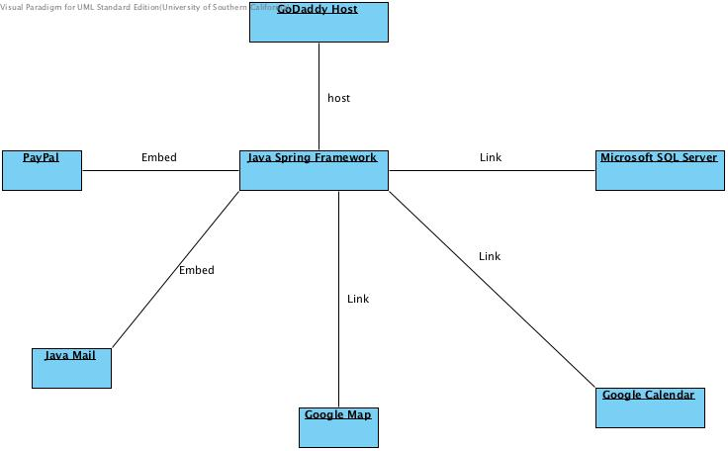
Figure 4 System Structure Diagram

Evaluation Summary
Table 4: NDI Evaluation
NDI | Usages | Comments
Java Spring Framework | Development framework providing back-end MVC architecture, and the port to connect database server. | Positive Points:  - Currently used  - Widely used  - More testable  Negative Points:  - Too many code to maintain
Microsoft SQL Server | Provide the database to store and manage the information about doctors and surgery centers. | Positive Points:  - Current Used  - Better secure and scalable, famous in enterprise  Negative Points:  - Bad consistency of distributed transactions across databases  - Not open source
Apache Tomcat Server | To provide web server to support Spring framework. | Positive Points:  - No extra expense on software  - Perfectly support Spring framework  Negative Points:  - Less optimal performance  - Low concurrency
JDBC | To provide database connection between database server and Java Spring Framework. | Positive Points:  - Perfectly support Spring Framework  - Widely used.  Negative Points:  - Hard to maintain.
Google Calendar | Provide a friendly user interface to display the reservation schedule of a doctor, and the posted surgical slots timetable of a surgery center. | Positive Points:  - Widely used thus can be, better for synchronizing with user’s personal calendar  - Inter component compatibility  - Easy to use  Negative Points:  - Less Optimized in categorize and search
Google Map | Provide a friendly user interface to display the location information of searched Surgery Centers | Positive Points:  - Widely used  - Accurate and up-to-date  Negative Points:  - N/A based on our requirement.
PayPal | Provide a financial platform to process the payments activity | Positive Points:  - Widely Used  - Highest security  Negative Points:  - High transaction fee on every single purchase
jQuery | Provide front-end interactive implementation library | Positive Points:  - Excellent interactive and animation  - Widely Used  - Free  Negative Points:  - Decrease performance
Bootstrap | Provide front-end layout implementation development framework | Positive Points:  - Provides a clean and elegant GUI  - Free  Negative Points:  - Likely to have namespace bugs
JavaMail | Provide the email implementation for notification feature of our system | Positive Points:  - Compatible with most of email protocol  - Build within Java EE platform  Negative Points:  - Less fault tolerate

Technology-Specific System Design

Design Overview

System Structure
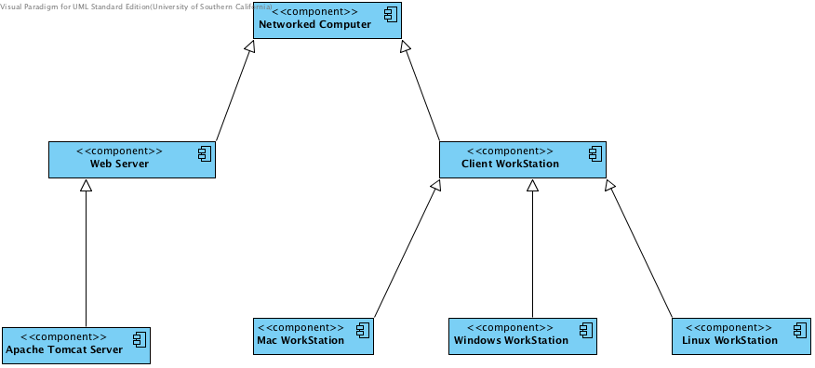
Figure 5 Hardware Component Class Diagram
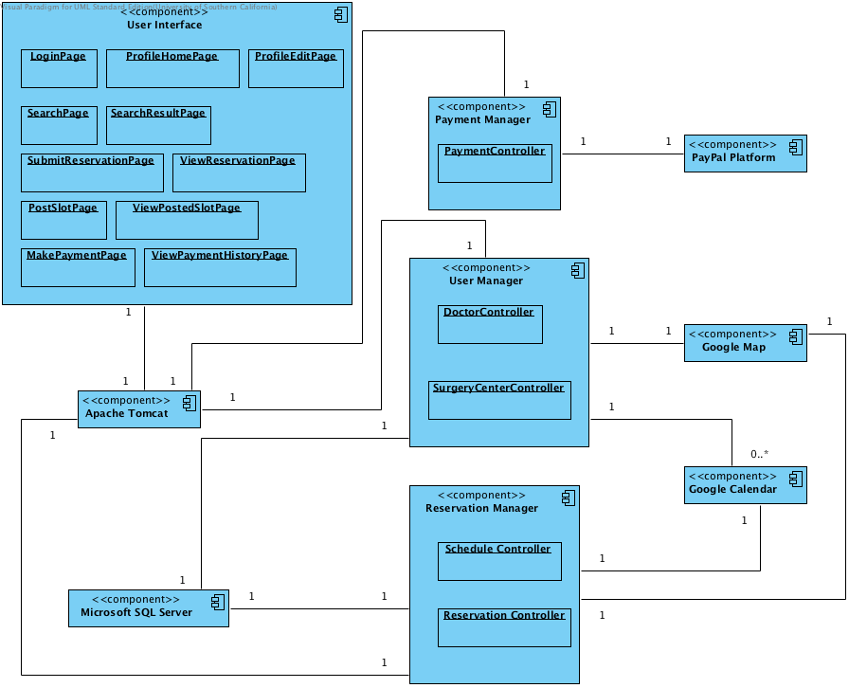
Figure 6 Software Component Class Diagram
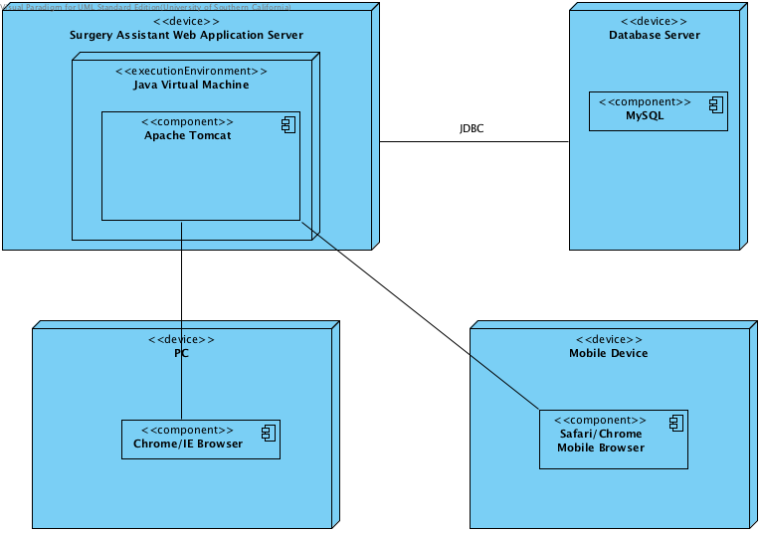
Figure 7 Deployment Diagram

Design Classes

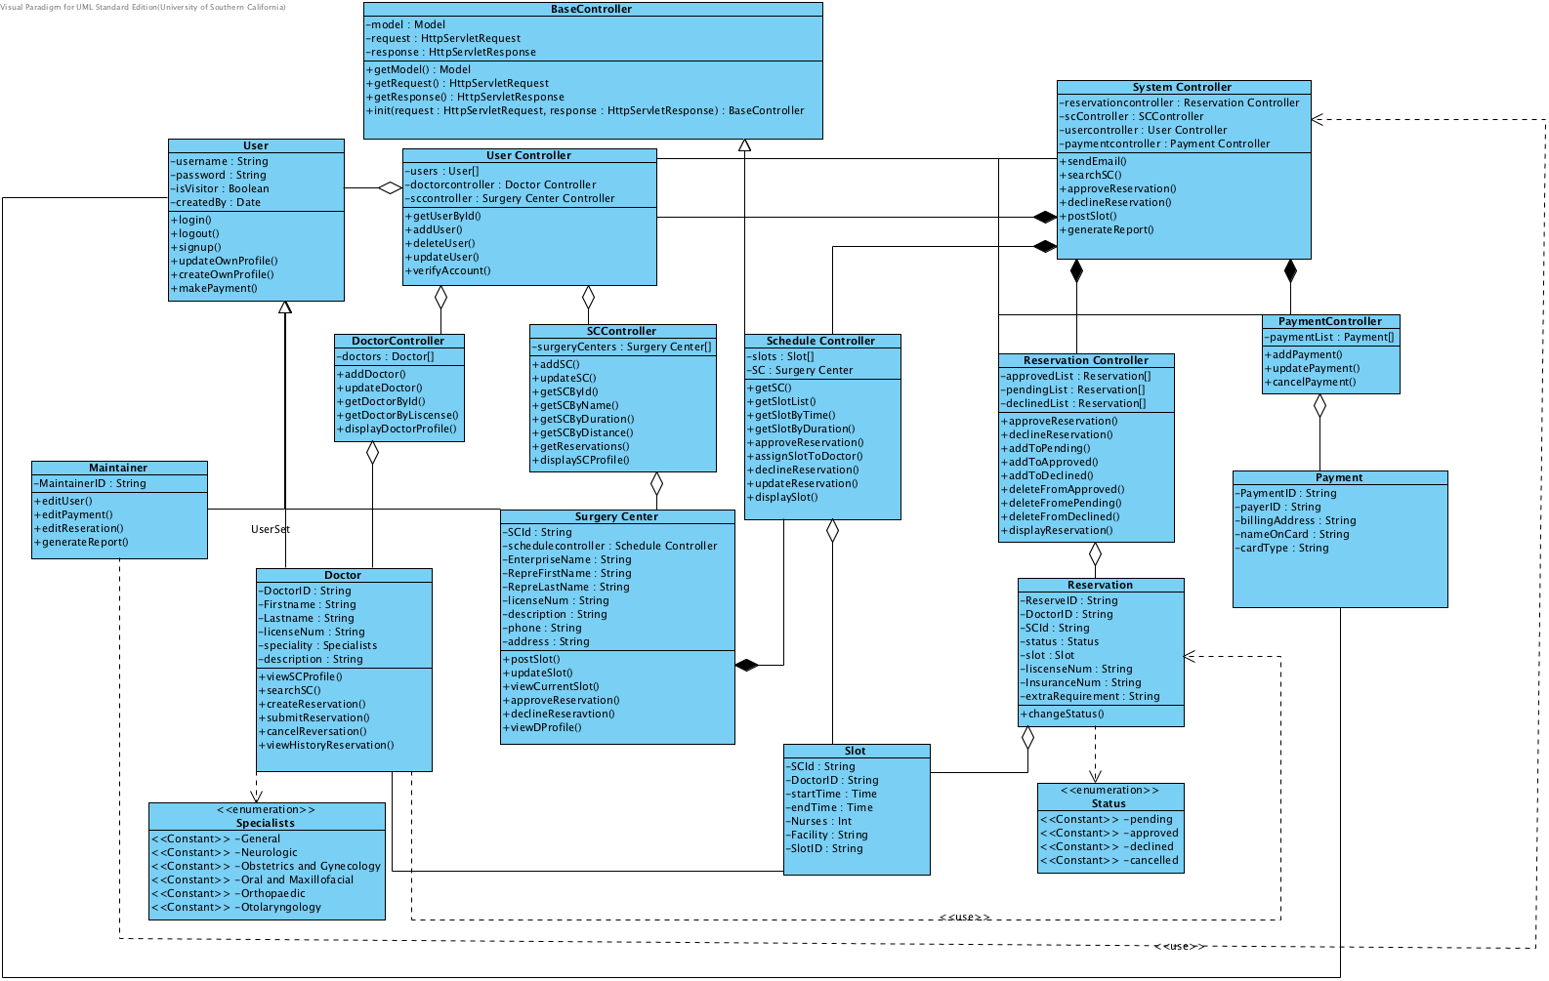
Figure 8 Design Class Diagram

Process Realization
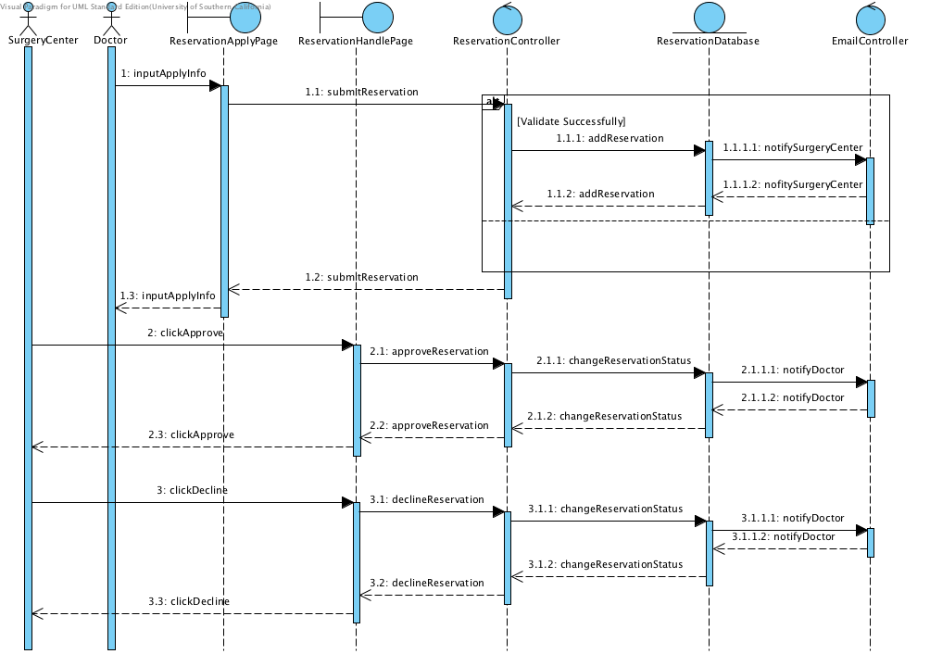
Figure 9 Reservation Sequence Diagram
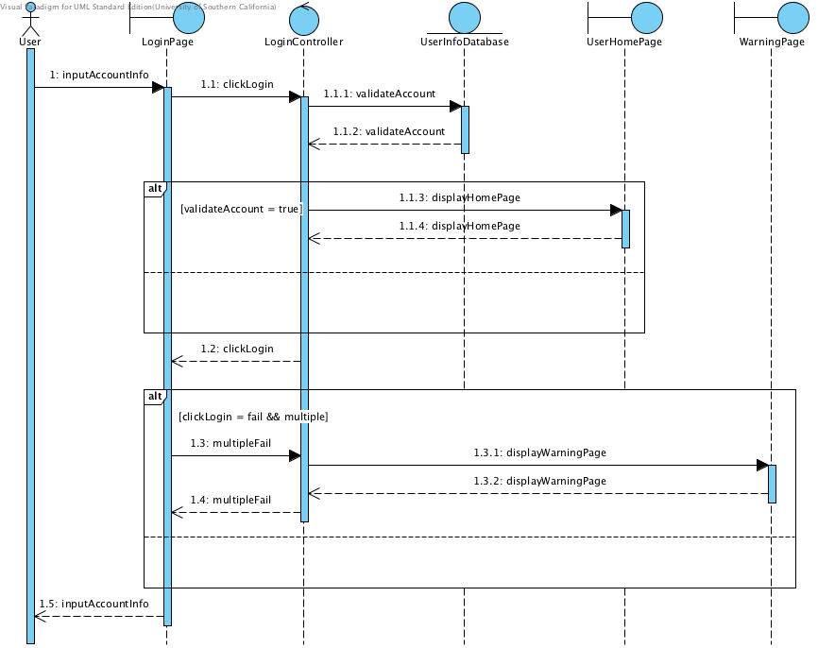
Figure 10 Login Sequence Diagram

